# CS 255 System Design Document Template

This template lays out all the different sections that you need to complete for Project Two. Each section has guidance to prompt your thinking. You will need to continually reference the interview transcript as you work to make sure that you are addressing your client’s needs. There is no required length for the final document. Instead the goal is to complete each section based on what your client’s needs are. Remove this note when you are finished, and replace all bracketed text with the relevant information.

## UML Diagrams

### UML Use Case Diagram

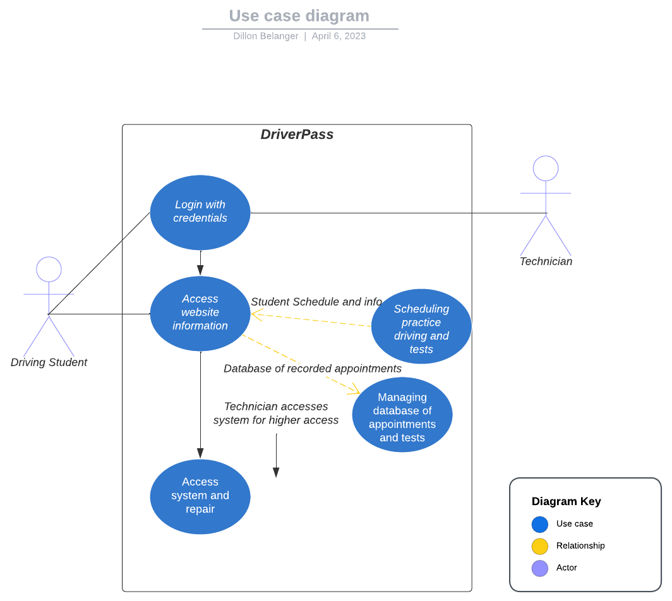

### UML Activity Diagrams

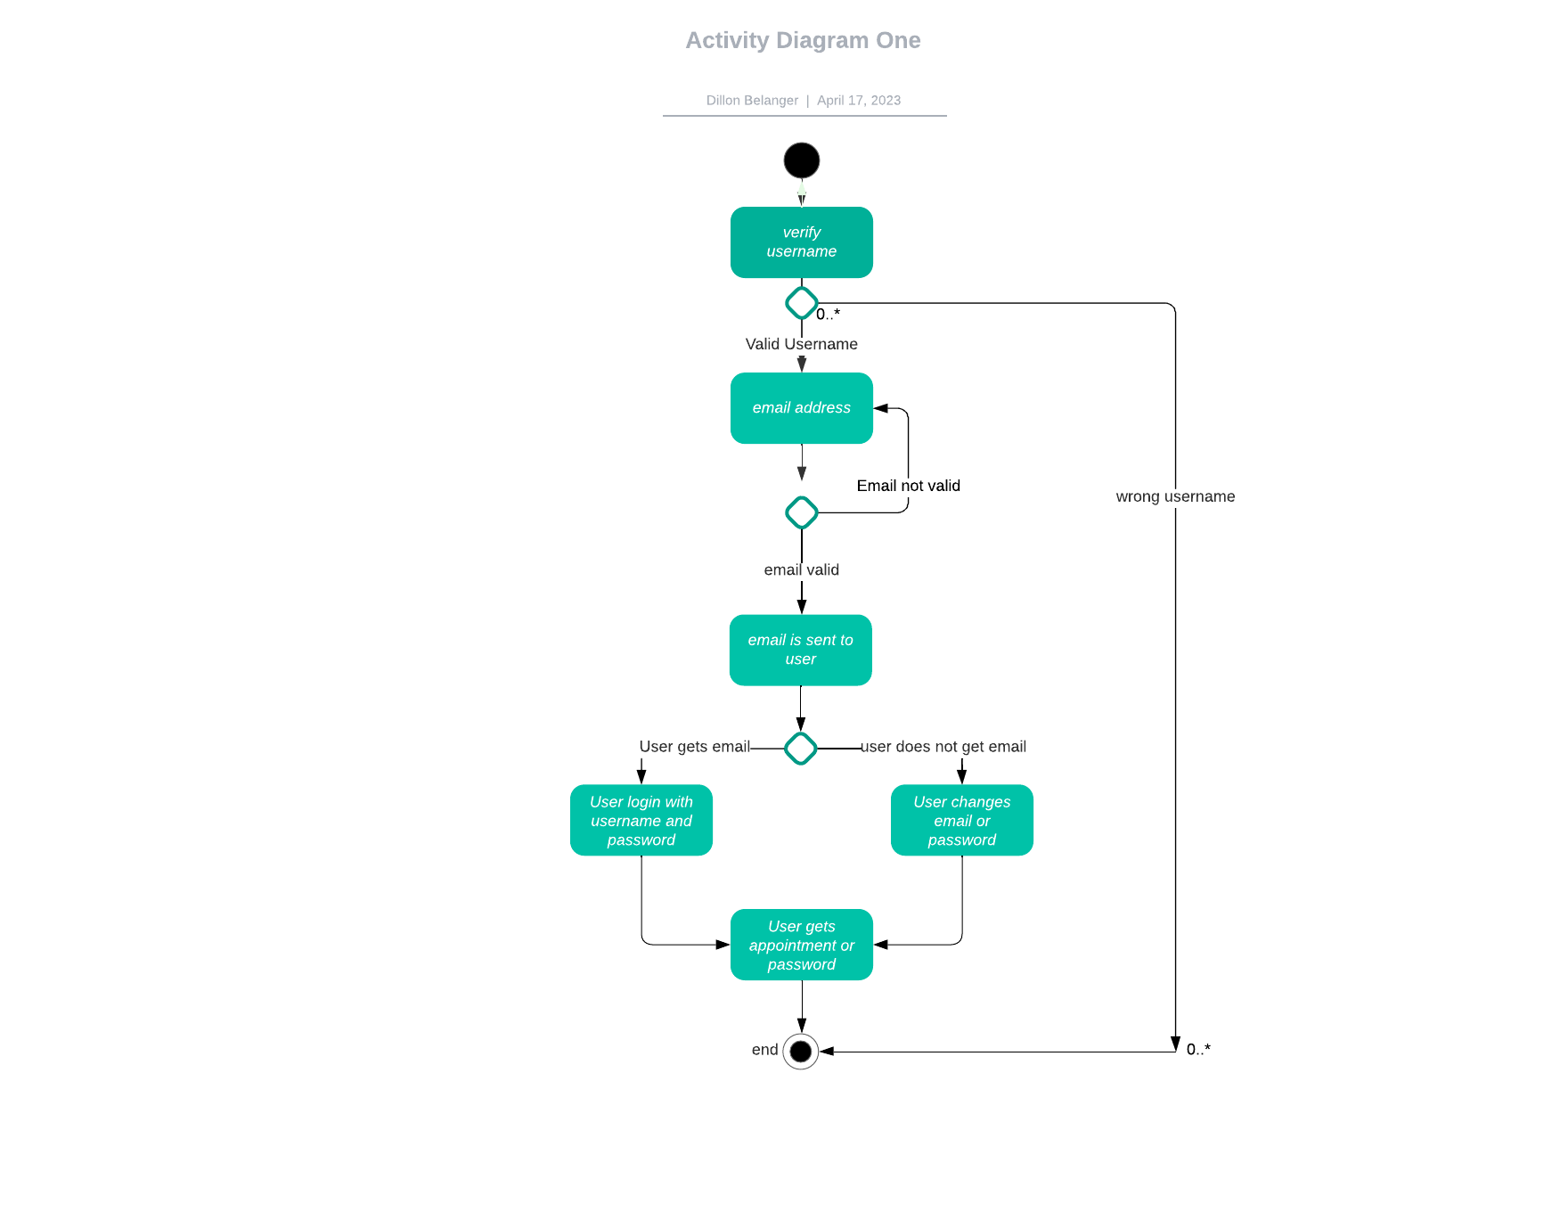

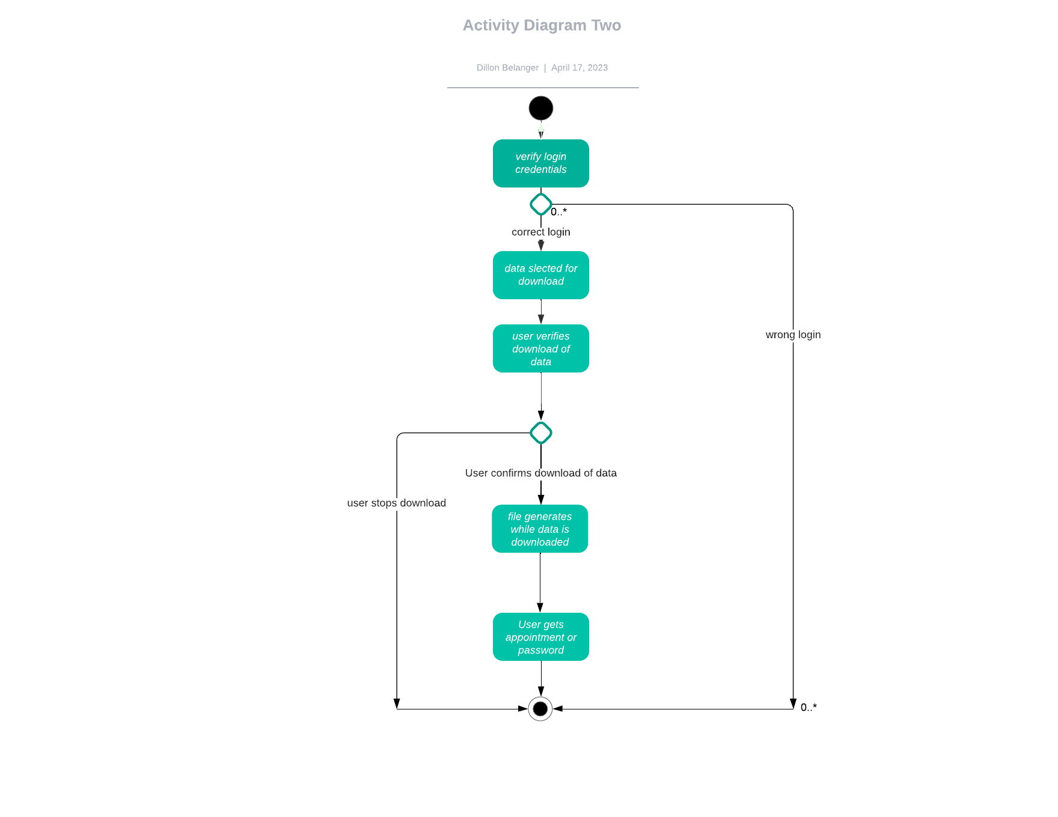

### UML Sequence Diagram

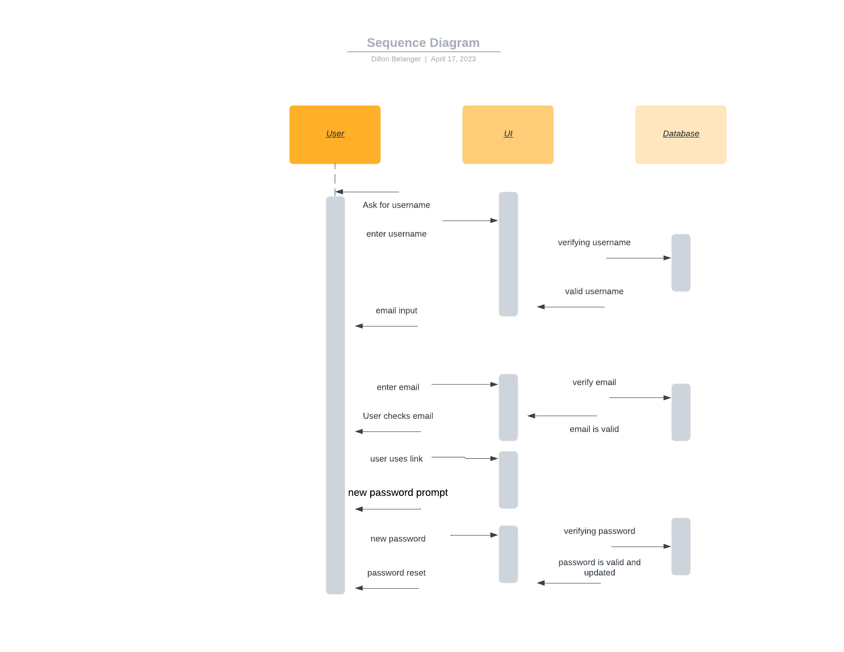

### UML Class Diagram

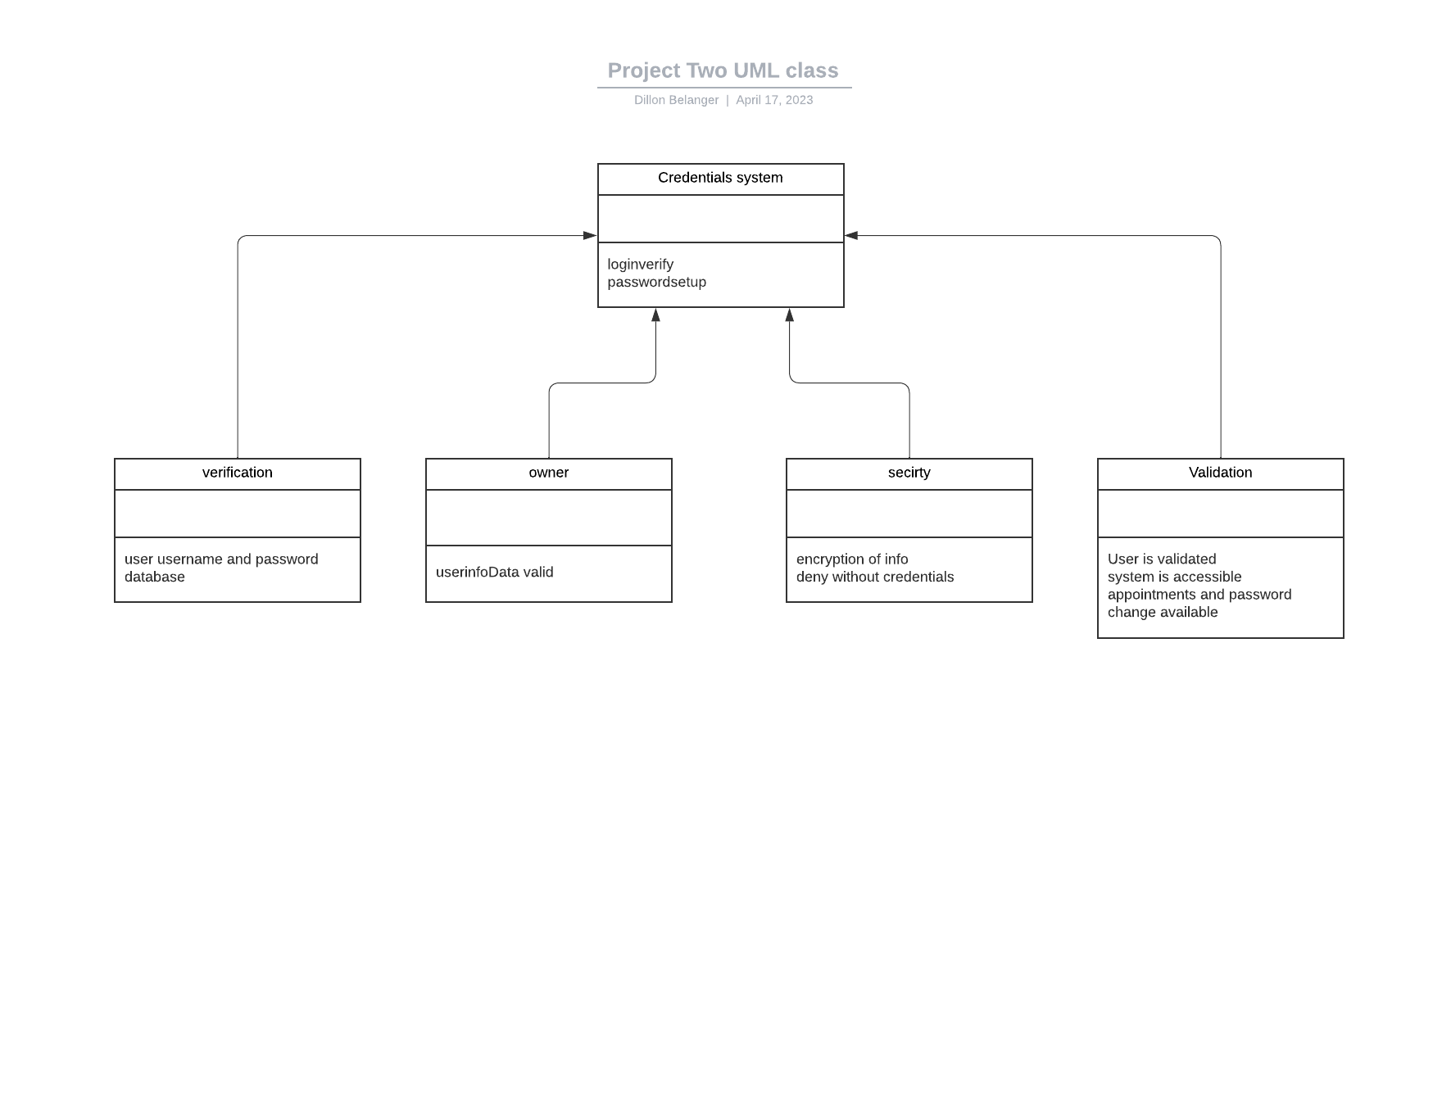

## Technical Requirements

For system functionality there needs to be development for the cloud and mobile versions. The owner must have valid credentials to use and change the data within the system. A database with cloud or physical servers is needed to store login information as well as others. Data transferred between the user and system must be encrypted for security reasons. A cloud-based platform will allow accessible updates more consistently regarding a training calendar for appointments and user’s progress. Role-based access will be implemented as well for the owner to adjust changes and normal users/customers cannot.